THE FEMALE REPRODUCTIVE SYSTEM

**FUNCTIONS OF THE FEMALE REPRODUCTIVE SYSTEM:**

1. ______________________________________________________________________________
2. ______________________________________________________________________________
3. ______________________________________________________________________________

**STRUCTURES OF THE FEMALE REPRODUCTIVE SYSTEM:**

|  |  |  |
| --- | --- | --- |
| **STRUCTURE** | **FUNCTION** | **COLOR** |
| OVA/OVUM |  |  |
| OVARIES |  |  |
| FALLOPIAN TUBE |  |  |
| UTERUS |  |  |
| CERVIX |  |  |
| VAGINA |  |  |

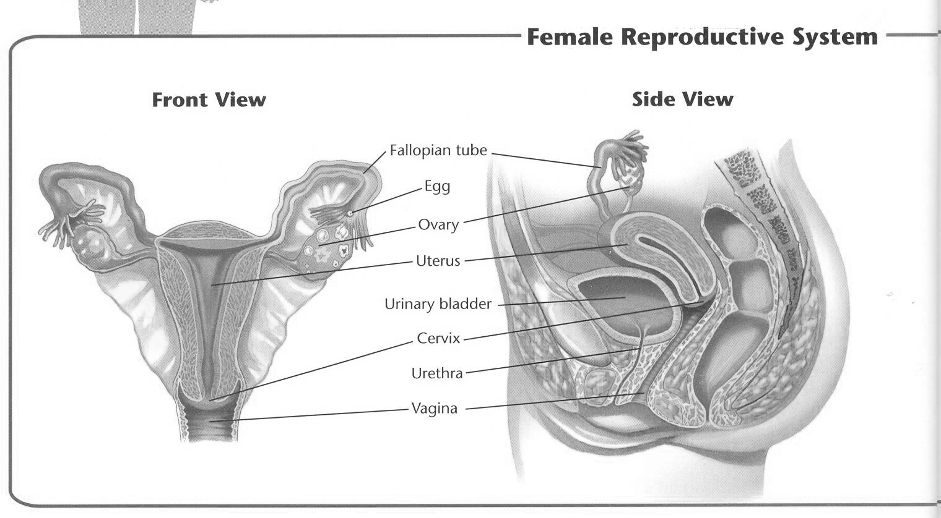

THE MENSTRUAL CYCLE

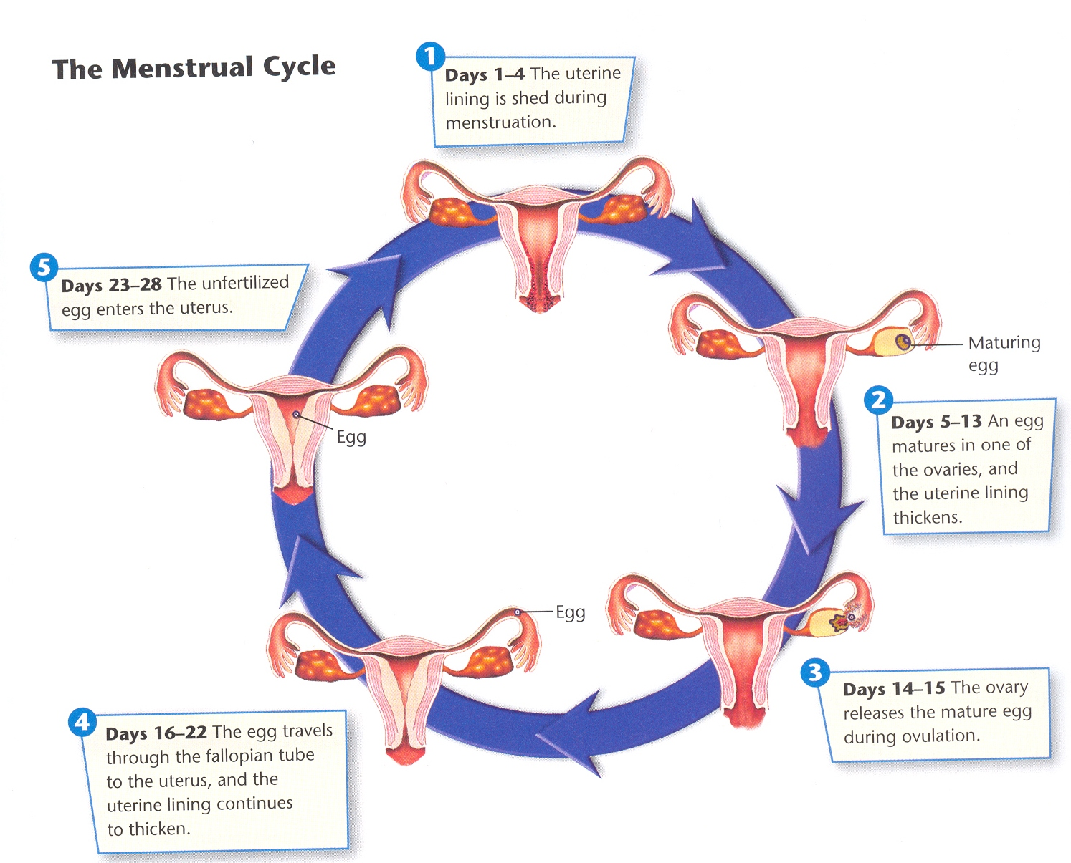

|  |  |  |
| --- | --- | --- |
| 1 | Days 1-4 |  |
| 2 | Days 5-13 |  |
| 3 | Days 14-15 |  |
| 4 | Days 16-22 |  |
| 5 | Days 23-28 |  |

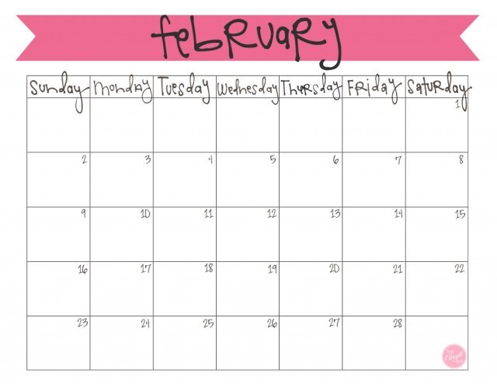

|  |  |
| --- | --- |
| **KEEPING HEALTHY** | |
| **DO’s** | **DON’TS** |
|  |  |
|  |  |
|  |  |
|  |  |
|  |  |
|  |  |
|  |  |
|  |  |
|  |  |
|  |  |
|  |  |

TICKET OUT

TICKET OUT